Jay Converse
Data Mining Homework 2
March 22, 2010

1) While most methods attempted performed almost as well as this method, bagging a J48 tree on a 10-fold evaluation provided the best results for this data:

TP Rate FP Rate Precision Recall F-Measure ROC Area Class
0.87 0.279 0.819 0.87 0.843 0.892 <50
0.721 0.13 0.793 0.721 0.755 0.892 >50_1
Weighted Avg. 0.809 0.218 0.808 0.809 0.807 0.892

This was the best balance between true positives and false negatives that I was able to find. A few had higher true positive rates with the drawback of much higher false positive rates.

2)
J48 alone: a b <-- classified as
104 22 | a = b
8 217 | b = g

Bagging: a b <-- classified as
105 21 | a = b
3 222 | b = g

Boosting: a b <-- classified as
97 29 | a = b
3 222 | b = g

Based on these results, Bagging at 50% bag size appears to be the most predictive model, based on our test data.

3)

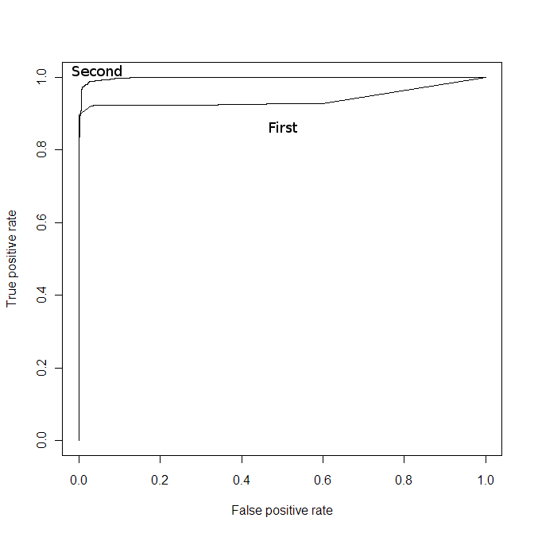
As shown in the diagram, while both predictors are pretty good predictors, the one provided by the second column of the data file is a much more reliable one. Both of them get to very high TPR rates with a low FPR, but the first predictor spends most of its time staying about 10% below the second one's TPR rate.

5)

=== Detailed Accuracy By Class ===

TP Rate FP Rate Precision Recall F-Measure ROC Area Class
0.968 0.672 0.927 0.968 0.947 0.736 0
0.328 0.032 0.539 0.328 0.408 0.736 1
Weighted Avg. 0.903 0.607 0.888 0.903 0.893 0.736

According to these results, by itself, J48 classification produces a reasonable true positive rate on non-defectors, but a massive false-positive rate on them, and a rather low true-positive rate on defectors. This indicates that this model does a bad job of predicting the defectors, which is the opposite of what we want it to do.

When a much smaller number of non-defectors is chosen, but still more than the defectors (undersampling the non-defectors), the result is:

=== Detailed Accuracy By Class ===

TP Rate FP Rate Precision Recall F-Measure ROC Area Class
0.86 0.239 0.878 0.86 0.869 0.84 0
0.761 0.14 0.731 0.761 0.746 0.84 1
Weighted Avg. 0.827 0.206 0.829 0.827 0.828 0.84

This results in much smaller true false positive rates for both classes, a much higher true positive rate for defectors, and a lower true positive rate for non-defectors. This is closer to a desirable outcome, but if it is strongly desired to not have non-defectors be called defectors, then this rate of .239 for that situation is still rather high.

When the defector data and non-defector data are resampled to have equal amounts of each class (oversampling the defectors), the results are:

=== Detailed Accuracy By Class ===

TP Rate FP Rate Precision Recall F-Measure ROC Area Class
0.882 0.023 0.974 0.882 0.926 0.947 0
0.977 0.118 0.892 0.977 0.932 0.947 1
Weighted Avg. 0.929 0.071 0.933 0.929 0.929 0.947

These results indicate a much higher overall accuracy of predictions. The only issue with this class is the 11.8% likelihood of a false positive on defectors; this might be too high for some applications that try to minimize the amount of people who are falsely flagged as defectors.

When cost-sensitive bagging of J48 is used using the cost matrix of

5 -5
-5 -500

to emphasize that a false positive on a non-defector is VERY bad, a false positive or false true is mildly bad, and a true positive is good, the results are:

=== Detailed Accuracy By Class ===

TP Rate FP Rate Precision Recall F-Measure ROC Area Class
0.971 0.67 0.928 0.971 0.949 0.895 0
0.33 0.029 0.562 0.33 0.416 0.895 1
Weighted Avg. 0.906 0.605 0.891 0.906 0.895 0.895

This method, again, has a high incidence of true positives but also of falsely marking a defector as a non-defector; however, this method still has a higher chance of marking a defector as a defector than J48 by itself.

