Jay Converse
Data Mining
Homework 3

1 and 2.

Dataset 1:

Would choose 3 means for this set. DBScan finds 3 clusters for this set.

Dataset 2:

Would choose 5 means for this set given the range between 2 and 5. DBScan finds one gigantic cluster containing all the points, or if epsilon is reduced, starts leaving points unclustered. This data appears to be random.

3.

Dataset 1:

a. For K-means, the correlations between cluster number and the 5 attributes are

0.7646811 0.7667039 0.7675641 0.7529606 0.7533815

These appear to be “decent” clusters, but probably could be better.

For Dbscan, the correlations between cluster number and the 5 attributes are

-0.5159454 -0.5166719 -0.5168174 -0.5158874 -0.5160993

These appear to be worse clusters than the K-means clusters.

b.

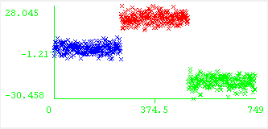
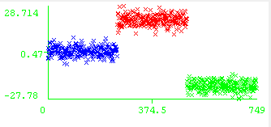
Above are screenshots of the correlation between instance number and attributes 1 and 3. Attributes 2, 4, and 5 all have similar graphs.

Dataset 2:

For 5 K-means, the correlations between cluster number and the 5 attributes are

0.43857767 0.45939782 0.03992416 0.08830730 -0.33284819
This data's correlation ranges from “bad to worse”, and doesn't appear to be correlated much at all.
DBScan, since it only finds one cluster, has a correlation of 1 between everything because it's all in the same cluster!
b. Below is a visualization of the cluster number against attribute 3. All graphs have similar “random appearances”.

