Jay Converse

STAT 344

Homework 4

46.

a. 0.2785858
b. 0.279
c. 0.7451136
d. 0.774841

50.

a. 0.561
b. 0.183
c. 0.622
d. 0.439

56.

a. 0.308
b. 0.397
c. 0.089
d. 0.911
e. 77.85

62.

a. When p = the expected value, the variance will equal 0.
b. Maxes at .5.

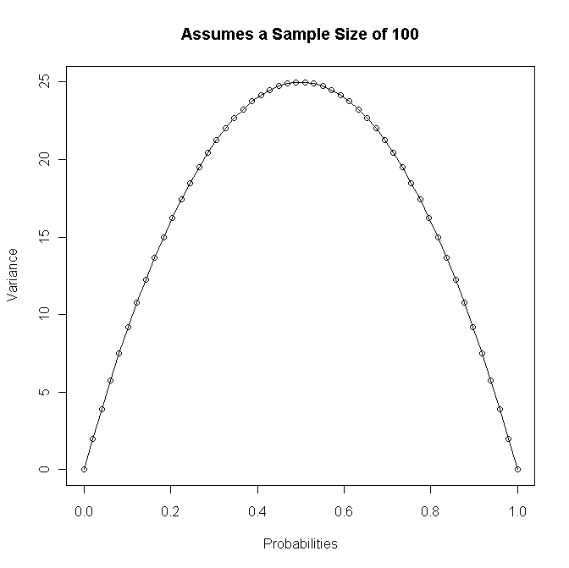

68. Hypergeometric. n=15, M = 6, N = 9,
b. P(x=2) = 0.42, p(x<=2) = 0.713, p(x >= 2) = 0.706.
c. Mean value is 3.333... and standard dev is 0.555...

72.
a. Using R notation, the probability that x of the top 4 were chosen is (choose(4,x)*choose(3,6-x))/choose(7,6).
b. 3.429.

75.
a. Using R notation, the probability of x males is choose(x + 1, 1).5^2(.5)^x.
b. 0.078.
c. 0.641.
d. You would expect this family to have 2 children.

80.
a. 0.191.
b. 0.525.
c. 0.184.

86.
a. 0.44.
b. 0.56.
c. 6.66...

91.
a. .221.
b. 6,800,000 trees.
c. The pmf is 1.

